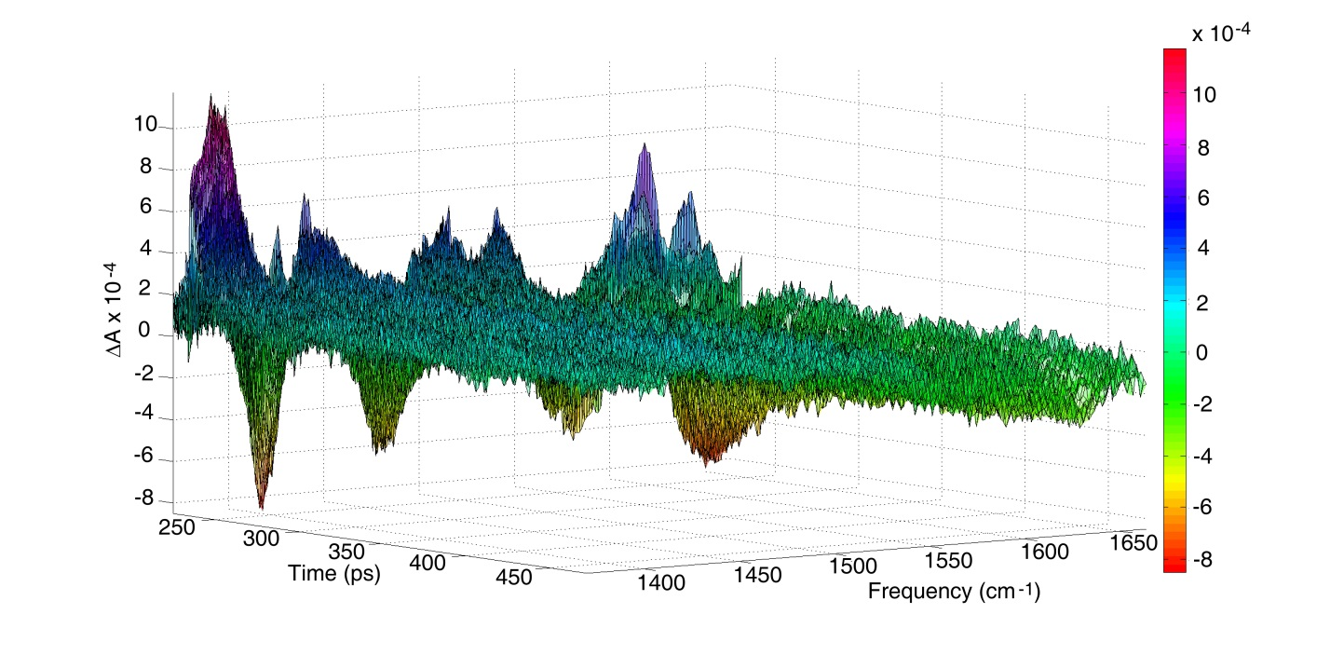

**Fig. 1.** Three-dimensional absolute TRIR spectrum of MetHb in D2O, plotted as Abs (z-axis), time in picoseconds (x-axis), and frequency in cm-1 (y-axis).

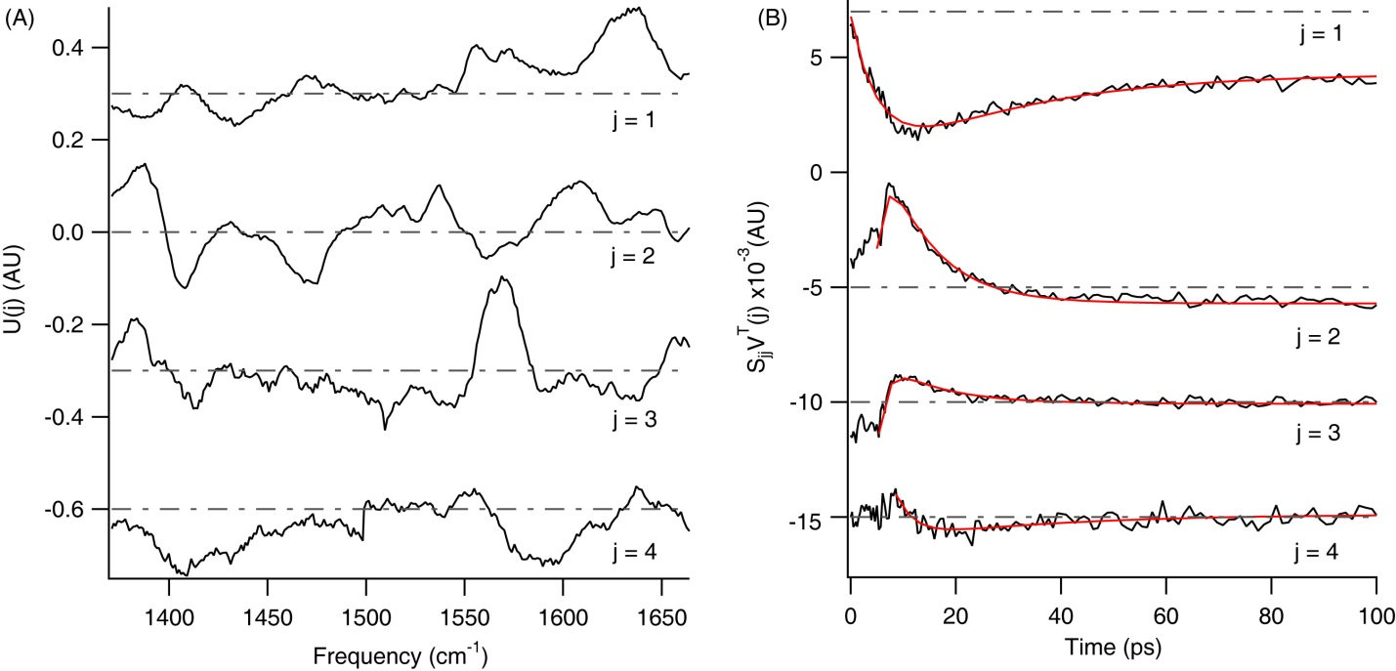

**Fig. 2.** Singular Value Decomposition component analysis for MetHb in D2O, truncated to the first four components (j = 1-4). (A) Spectral components of the data given by the U(j) vectors. (B) Transient components of the data given by the VT(j) vectors, which are multiplied by their singular values Sjj. Transient fit curves are overlaid in red. The U(j) vectors and SjjVT(j) vectors are offset for clarity, with zero lines indicated by gray dot-dashed lines.

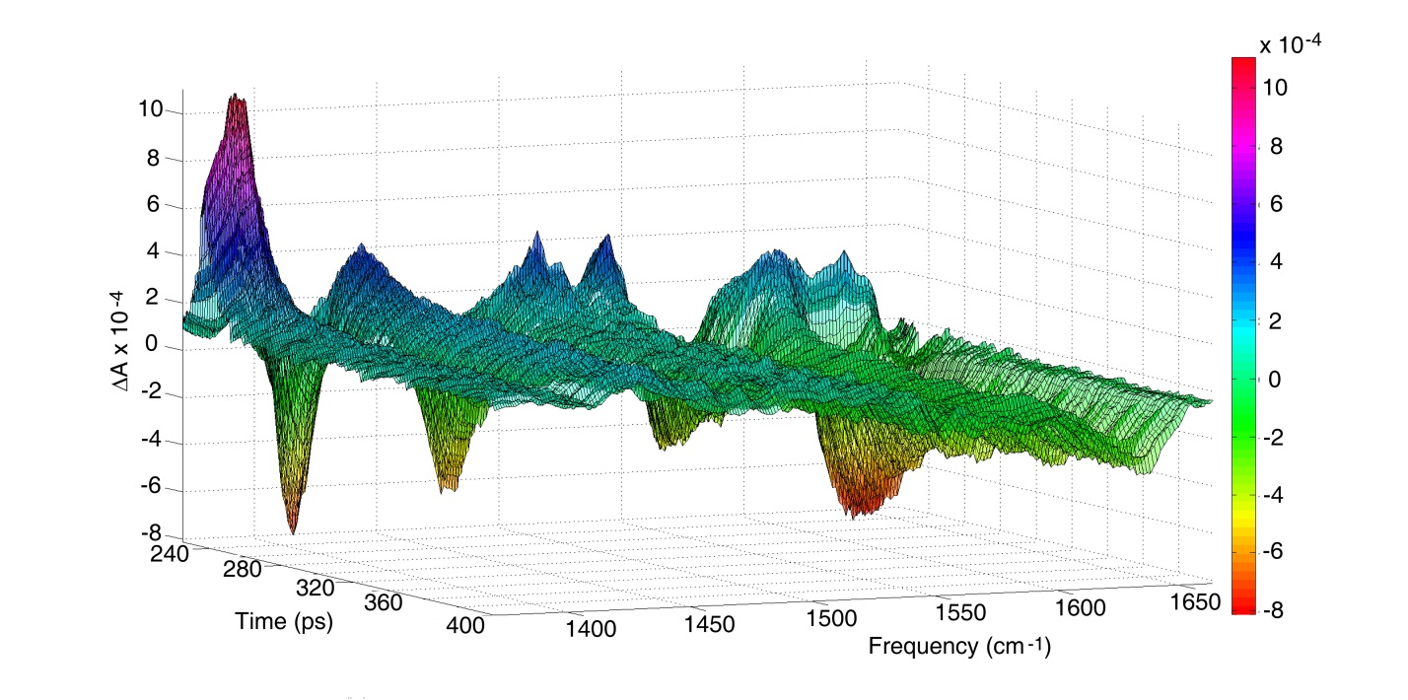

**Fig 3.** Three dimensional TRIR spectrum of MetHb in D2O reproduced by SVD as U(j)SjjVT(j), truncated to the first four SVD components.

|  |  |  |  |  |  |
| --- | --- | --- | --- | --- | --- |
| **SjjVT(j)** | **A1** | **1 (ps)** | **A2** | **2 (ps)** | **avg (ps)** |
| **j = 1**  **exp**  **bleach** | 5.8e-3 ± 7e-4 | 7.1 ± 1.9 | -- | -- | -- |
| **j = 1**  **exp**  **decay** | 3.3e-3 ± 5e-5 | 26.9 ± 0.8 | -- | -- | -- |
| **j = 1**  **bi-exp**  **whole trace** | 6.8e-3 ± 3e-4 | 4.4 ± 0.3 | -5.9e-3 ± 3e-4 | 23.5 ± 1.2 | -- |
| **j = 2**  **exp**  **decay** | -4.2e-3 ± 8e-5 | 6.8 ± 0.2 | -- | -- | -- |
| **j = 3**  **exp**  **bleach** | 2.7e-2 ± 1e-3 | 1.0 ± 0.2 | -- | -- | -- |
| **j = 3**  **exp**  **decay** | -1.4e-3 ± 8e-5 | 15.9 ± 1.6 | -- | -- | -- |
| **j = 3**  **bi-exp**  **decay** | -1.0e-3 ± 1e-4 | 4.5 ± 1.5 | -6.7e-4 ± 2e-4 | 37.2 ± 10.2 | 17.3 |
| **j = 3**  **bi-exp**  **whole trace** | 3.2e-3 ± 2e-4 | 1.1 ± 0.2 | 2.1e-3 ± 1e-4 | 14.8 ± 1.3 | -- |
| **j = 4**  **exp**  **bleach** | 2.1e-3 ±  1e-4 | 4.2 ± 0.6 | -- | -- | -- |
| **j = 4**  **exp**  **decay** | -8.1e-4 ± 4e-5 | 38.4 ± 3.7 | -- | -- | -- |
| **j = 4**  **exp**  **whole trace** | 2.6e-3 ± 1e-4 | 4.5 ± 0.4 | -1.4e-3 ± 1e-4 | 35.3 ± 3.5 | -- |

**Table 1.** Exponential fitting results to the bleach component, decay component, and whole traces of each SjjVT(j) vector for MetHb in D2O.

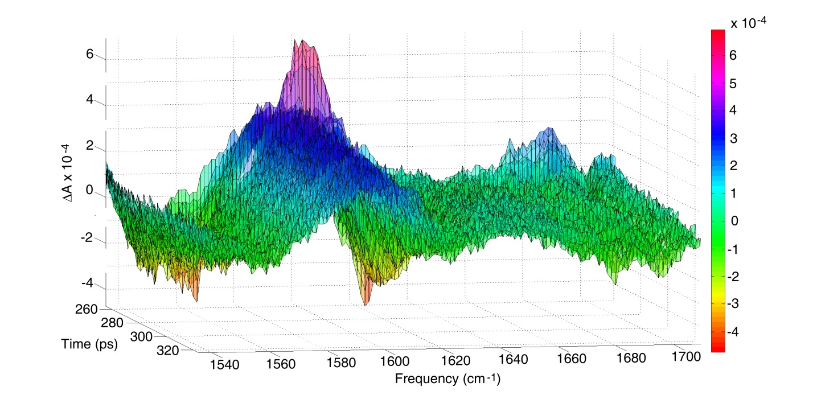

**Fig. 4.** Three-dimensional absolute TRIR spectrum of MetHb in ethylene glycol/D2O (0.2 mole fraction), plotted as Abs (z-axis), time in picoseconds (x-axis), and frequency in cm-1 (y-axis).

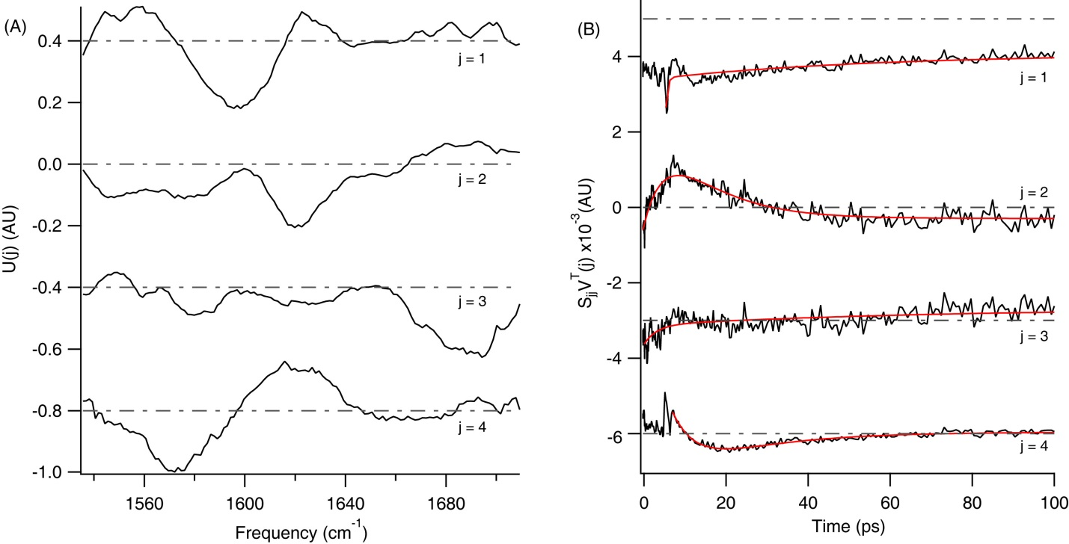

**Fig. 5.** Singular Value Decomposition component analysis for MetHb in ethylene glycol/D2O (0.2 mole fraction), truncated to the first four components (j = 1-4). (A) Spectral components of the data given by the U(j) vectors. (B) Transient components of the data given by the VT(j) vectors, which are multiplied by their singular values Sjj. Transient fit curves are overlaid in red. The U(j) vectors and SjjVT(j) vectors are offset for clarity, with zero lines indicated by gray dot-dashed lines.

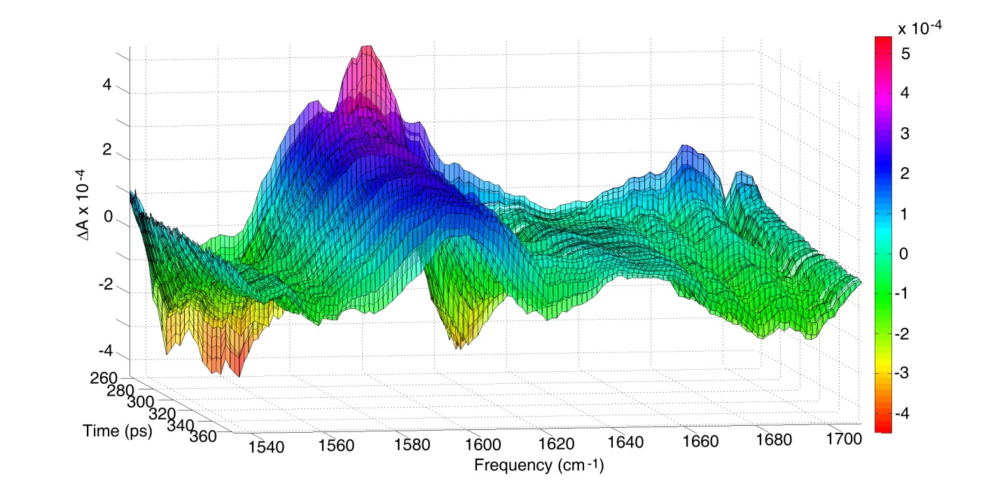

**Fig 6.** Three dimensional TRIR spectrum of MetHb in ethylene glycol/D2O (0.2 mole fraction) reproduced by SVD as U(j)SjjVT(j), with j truncated to the first four SVD components.

|  |  |  |  |  |  |
| --- | --- | --- | --- | --- | --- |
| **SjjVT(j)** | **A1** | **1 (ps)** | **A2** | **2 (ps)** | **avg (ps)** |
| **j = 1**  **exp**  **decay** | 7.3e-4 ± 1e-5 | 29.4 ± 2.2 | -- | -- | -- |
| **j = 1**  **bi-exp**  **decay** | 8.0e-4 ± 1e-4 | 0.4 ± 0.1 | 6.4e-4 ± 3e-5 | 53.7 ± 7.3 | 24 |
| **j = 2**  **exp**  **bleach** | -2.0e-3 ± 4e-4 | 5.3 ± 2.0 | -- | -- | -- |
| **j = 2**  **exp**  **decay** | 1.4e-3 ± 6e-5 | 14.8 ± 1.1 | -- | -- | -- |
| **j = 2**  **bi-exp**  **whole trace** | -4.5e-3 ± 2e-3 | 5.4 ± 1.2 | 4.3e-3 ± 2e-3 | 12.0 ± 2.3 | -- |
| **j = 3**  **exp**  **decay** | -6.5e-4 ± 4e-5 | 35.5 ± 6.0 | -- | -- | -- |
| **j = 3**  **bi-exp**  **decay** | -5.0e-4 ± 1e-4 | 3.1 ± 0.8 | -4.6e-4 ± 5e-5 | 69.2 ± 17.4 | 34.8 |
| **j = 4**  **bleach** | 1.0e-3 ± 3e-5 | 3.7 ± 0.3 | -- | -- | -- |
| **j = 4**  **decay** | -5.0e-3 ± 2e-5 | 22.2 ± 1.8 | -- | -- | -- |
| **j = 4**  **bi-exp**  **whole trace** | 1.7e-3 ± 2e-4 | 5.8 ± 0.6 | -1.2e-3 ± 2e-4 | 19.6 ± 2.1 | -- |

**Table 2.** Exponential fitting results to the bleach component, decay component, and whole traces of each SjjVT(j) vector for MetHb in ethylene glycol/D2O (0.2 mole fraction).